B, C, E, F, FF, G
B, A, Q
Q, ON, M
M, K, J, I
I, H, G

C – D – E – F
F – FF – G
G -H
H – I
I – J
J – L – M
M - N – O – P – Q
Q – R – S – A – B - C

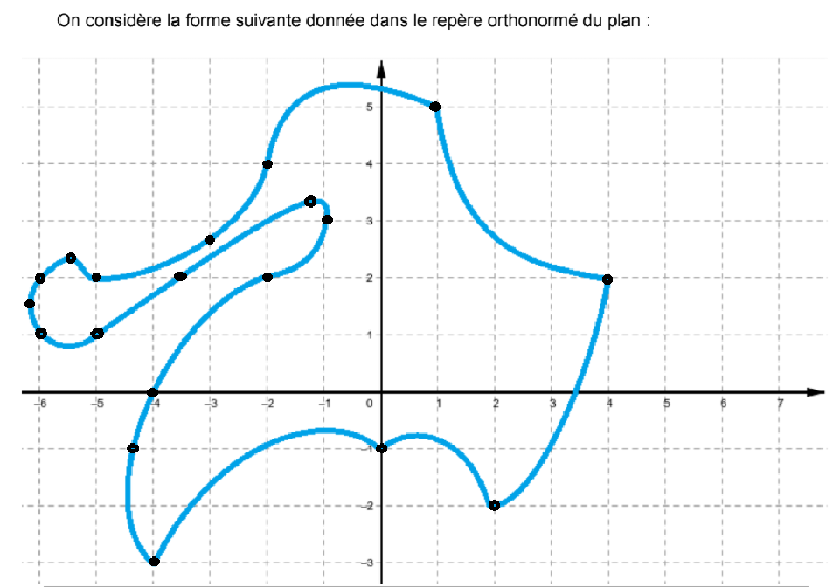
A
B
C
D
E
F
G
H
I
J
K
L
M
N
O
P
Q
R
S
FF

